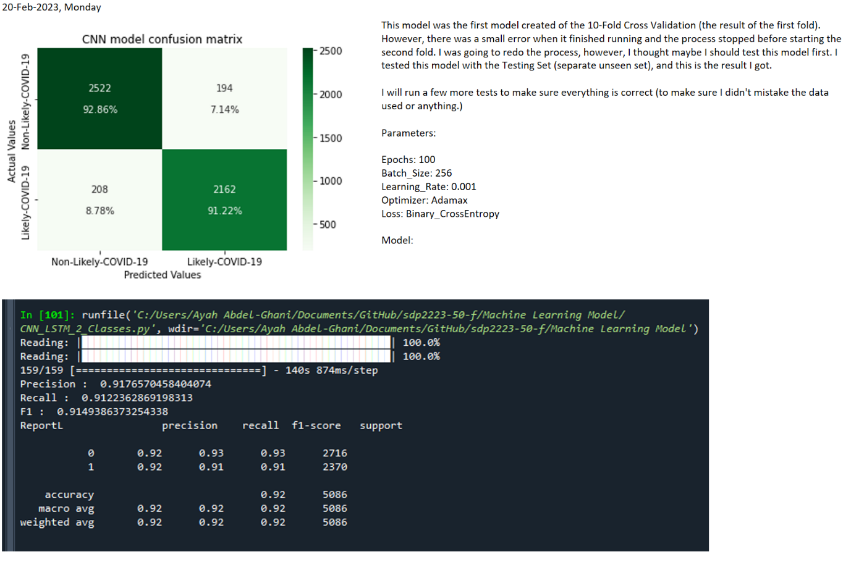

Model:

Model: "model_1"

_________________________________________________________________

Layer (type) Output Shape Param #

=================================================================

input (InputLayer) [(None, 39, 88, 3)] 0

conv2d_4 (Conv2D) (None, 38, 87, 16) 208

average_pooling2d_4 (Averag (None, 37, 86, 16) 0

ePooling2D)

batch_normalization_5 (Batc (None, 37, 86, 16) 64

hNormalization)

activation_7 (Activation) (None, 37, 86, 16) 0

dropout_6 (Dropout) (None, 37, 86, 16) 0

conv2d_5 (Conv2D) (None, 36, 85, 32) 2080

average_pooling2d_5 (Averag (None, 35, 84, 32) 0

ePooling2D)

batch_normalization_6 (Batc (None, 35, 84, 32) 128

hNormalization)

activation_8 (Activation) (None, 35, 84, 32) 0

dropout_7 (Dropout) (None, 35, 84, 32) 0

conv2d_6 (Conv2D) (None, 34, 83, 64) 8256

average_pooling2d_6 (Averag (None, 33, 82, 64) 0

ePooling2D)

batch_normalization_7 (Batc (None, 33, 82, 64) 256

hNormalization)

activation_9 (Activation) (None, 33, 82, 64) 0

dropout_8 (Dropout) (None, 33, 82, 64) 0

conv2d_7 (Conv2D) (None, 32, 81, 128) 32896

average_pooling2d_7 (Averag (None, 31, 80, 128) 0

ePooling2D)

batch_normalization_8 (Batc (None, 31, 80, 128) 512

hNormalization)

activation_10 (Activation) (None, 31, 80, 128) 0

dropout_9 (Dropout) (None, 31, 80, 128) 0

reshape_1 (Reshape) (None, 31, 10240) 0

lstm_1 (LSTM) (None, 256) 10748928

activation_11 (Activation) (None, 256) 0

batch_normalization_9 (Batc (None, 256) 1024

hNormalization)

dropout_10 (Dropout) (None, 256) 0

dense_1 (Dense) (None, 100) 25700

activation_12 (Activation) (None, 100) 0

dropout_11 (Dropout) (None, 100) 0

output_layer (Dense) (None, 1) 101

activation_13 (Activation) (None, 1) 0

=================================================================

Total params: 10,820,153

Trainable params: 10,819,161

Non-trainable params: 992

_________________________________________________________________

Second Attempt:



